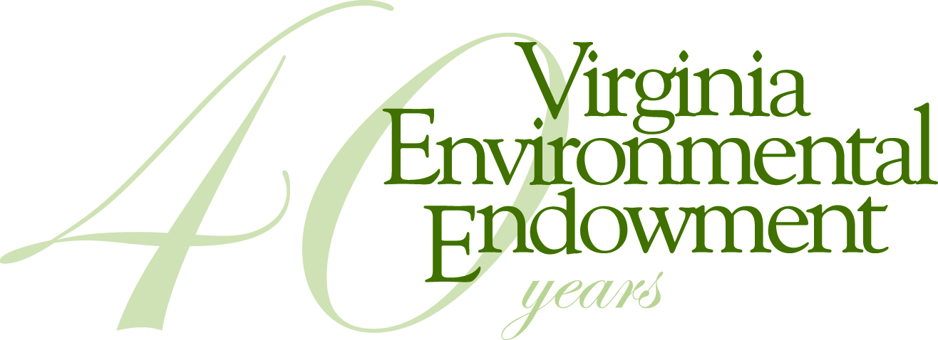

FOR IMMEDIATE RELEASE

Contact: Joseph H. Maroon, Executive Director
info@vee.org / 804.644.5000

VIRGINIA ENVIRONMENTAL ENDOWMENT AWARDS
MORE THAN A QUARTER MILLION DOLLARS FOR PROJECTS STATEWIDE

May 9, 2017 - The Virginia Environmental Endowment (VEE) today announced awards of $277,500 to 14 organizations dedicated to protecting and improving the Commonwealth’s natural resources and environment. When combined with matching funds, VEE has achieved more than $80 million in environmental improvements statewide since it was founded in 1977.

“As VEE celebrates its 40th anniversary, we are again honored to support partners whose work will make a difference in the quality of life, community health, and natural resource protection across Virginia. A recent Christopher Newport University poll of Virginia voters found that a strong majority say that environmental issues are very important to them personally, and that they want to see progress continued. Many of these grant projects will produce both local and statewide benefits for clean water and conservation of open spaces and natural resources,” said Joseph H. Maroon, VEE Executive Director.

Grants, listed by geography, include:

Charlottesville and Central VA
- Rivanna Conservation Alliance: Expand citizen water quality monitoring expertise and sites on the Rivanna and its tributaries. VEE funding will enable RCA to increase the level of state certification of its testing program and increase the number of monitoring sites. In recent years, the Virginia Department of Environmental Quality has seen budget cuts in its own water quality monitoring program, making citizen monitoring increasingly important. ($25,000)
- Southern Environmental Law Center: Support core programs in land use and transportation solutions that promote sustainable development and conservation statewide and defend regulations and programs that aim to restore the Chesapeake Bay and its tributaries. ($35,000)

Coastal Region/ Chesapeake Bay
- William & Mary Law School, Virginia Coastal Policy Center: Support for legal and policy research to assist local communities with resilience planning due to sea level rise, groundwater depletion, and recurrent flooding, and support for the Center’s annual conference. Included is work with the Southeast Community in Newport News, a vulnerable residential area that is subject to recurrent flooding. ($35,000)
- Virginia Institute of Marine Science/Virginia Sea Grant: In partnership with the Virginia Sea Grant Program and VIMS, establish the Commonwealth Coastal and Marine Policy Fellowship program, which will provide one-year opportunities for recent post-graduate students to serve within host state natural resources agencies. The first three Fellows will be placed in the Department of Environmental Quality, the Department of Conservation and Recreation, and the Marine Resources Commission. ($10,000 per year for two years)

Richmond/James River Basin
- James River Association: Produce an enhanced State of the James report, to provide a more comprehensive overview of the health of the James River in the fall of 2017. JRA will revise its report to include additional information on community benefits, health risks, toxic pollution, and local conditions that have not been part of its biennial progress reports to date. ($30,000)
- VIRGINIAforever: Conduct an updated study regarding how natural resources funding in Virginia’s state budget compares to other states. The last studies were conducted in 2002 and 2003 and found that Virginia ranked 50th in per capita spending on the environment at that time. ($12,500)
- Virginia United Land Trusts: Strengthen Virginia’s land conservation community by enhancing the statewide umbrella organization’s support of the state’s local land trusts, including efforts to sustain long-term conservation funding and stable tax credits. ($20,000)
- Virginia Association of Soil and Water Districts: Continued support and expansion of the Youth Conservation Leadership Institute to mentor high school students who have shown an increased interest in conservation and serving their communities. ($8,000)

Northern Virginia/Piedmont
- Friends of the Rappahannock: Support the Headwaters Stream Initiative to expand the organization’s work throughout the Rappahannock watershed. The grant will support trout restoration projects and work with property owners in six headwater counties to restore riparian buffers along streams and rivers. ($15,000)
- Piedmont Environmental Council: Advance a targeted land and water quality initiative seeking to improve the Goose Creek watershed in Loudoun and Fauquier counties, which is an important public drinking water source for Northern Virginia. ($16,000)

Shenandoah Valley
- Shenandoah National Park Trust on behalf of Blue Ridge PRISM: Support for an innovative education program aimed at increasing landowner awareness about the damage caused by non-native plants and encouraging replacement with native species in a 10 county region. ($15,000 Challenge Grant)

Southern and Southwest Virginia
- Black Family Land Trust: Support the Virginia Sustainable Forestry and African-American Land Retention Program to retain African-American owned forestland in the seven counties throughout southern Virginia. With this funding, BFLT will target historically underserved African American property owners with land assets in seven counties (Brunswick, Dinwiddie, Greensville, Halifax, Lunenburg, Mecklenburg, and Sussex). ($15,000 challenge grant)
- Upper Tennessee River Roundtable: Advance projects to improve water quality, and to provide educational resources in the Clinch River watershed in Tazewell County in southwest Virginia. ($6,000)
- Land Trust Alliance: Continue and expand upon work of a “circuit rider” professional land trust coach to strengthen land trusts in southern Virginia, and, in addition, provide training and support for land trusts in the Shenandoah, Upper Potomac, Rappahannock, Rapidan watersheds and Eastern Shore about how to effectively support Chesapeake Bay land and water quality improvement goals. ($25,000)

To learn more about the Endowment, or to obtain additional information about the complete list of projects or organizations receiving funding, please contact Joseph H. Maroon at info@vee.org or (804) 644.5000 or visit vee.org.

The Virginia Environmental Endowment (VEE) is a non-profit, grant-making foundation based in Richmond, Virginia that is focused on improving the quality of the environment by using its capital, expertise and resources to encourage all sectors to work together to prevent pollution, conserve natural resources and promote environmental literacy. The Endowment is celebrating its 40th Anniversary in 2017. Learn more about VEE by visiting vee.org.

