FOR IMMEDIATE RELEASE

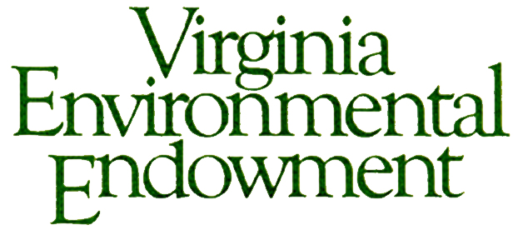
Contact:
Joseph H. Maroon
Executive Director
info@vee.org
(804) 644-5000

THE VIRGINIA ENVIRONMENTAL ENDOWMENT AWARDS
MORE THAN $240,000 FOR ENVIRONMENTAL IMPROVEMENTS

Grants awarded focus on enhancing water quality, restoring the Chesapeake Bay, and advancing land conservation, environmental literacy, and climate adaptation throughout Virginia

May 12, 2015 - The Virginia Environmental Endowment (VEE) today announced awards of more than $240,000 to protect and improve the region’s natural resources and environment. When combined with matching funds, grants awarded by VEE since 1977 represent an investment of over $76 million in environmental improvements statewide.

“The Endowment is once again honored to partner with so many outstanding organizations focused on tangible water quality improvements, the restoration of the Chesapeake Bay, land conservation, environmental literacy and climate adaptation across our great Commonwealth,” said Joseph H. Maroon, Executive Director. “This group of grant awards addresses some of Virginia's pressing environmental issues namely, protecting our rivers and neighboring communities from emerging chemical and rail transportation threats, targeting efforts to add additional conservation benefits to Virginia's protected lands in support of the Governor's Virginia Treasures initiative, and providing conservation assistance to a growing number of women who are principal farm and forest land owners."

VEE GRANT AWARDS IN THE COMMONWEALTH OF VIRGINIA

Improving Local Water Quality and the Chesapeake Bay
- James River Association: Support for the “Our River at Risk Campaign” to safeguard the river and neighboring localities from newly identified threats to its integrity. This project also supports VEE’s efforts to increase public awareness ($35,000 - Richmond and James River Watershed).
- Southern Environmental Law Center: Support for the defense of the Chesapeake Bay and its tributaries through implementation of the Bay TMDL, as well as the response to emerging challenges associated with threats to vulnerable landscapes such as the prospect of hydro-fracturing in coastal Virginia. This grant also supports VEE’s focus on sound land use policies ($35,000 - Charlottesville and Statewide).
- Friends of the Rappahannock: Support for three demonstration projects, engaging student volunteers, to implement living shorelines as an alternative to traditional shoreline protection measures. This project also supports VEE’s efforts to increase public awareness ($23,000 - Middle Peninsula and Northern Neck).
- Environmental Integrity Project: Support for the organization’s review of the agriculture verification plans for the Chesapeake Bay ($20,000 - Bay Region).

Conserving Virginia’s Lands
- Virginia Outdoors Foundation: Partnership with the Commonwealth of Virginia to digitize all land conservation easements, resulting in a searchable database to identify potential opportunities for additional water quality and environmental benefits on currently protected lands. This project supports the Governor’s Virginia Treasures initiative ($28,290 - Statewide).
- American Farmland Trust: Support for four pilot projects to help connect women landowners and farmers with financial and technical assistance for conservation ($20,000 - Dinwiddie County, Piedmont Region, Shenandoah Valley, and Southern Virginia).
- Capital Region Land Conservancy: Funding for strategic conservation in the middle James River watershed, focused on Powhatan and Goochland Counties ($10,000 - Richmond).
- New River Land Trust: Funding for continuation of land conservation services and expanded capacity in the New River Valley ($10,000 - Blacksburg).
- Middle Peninsula Chesapeake Bay Public Access Authority: Support for transaction costs associated with the voluntary donation of private land for shoreline protection and public access ($12,000 - Saluda and the Middle Peninsula).

Enhancing Environmental Literacy and Public Awareness
- Rappahannock Community College: Support to expand the Virginia Watermen's Heritage Environmental Training and Stewardship Program ($13,400 – Bay Region).
- NOTE: Several of the other grants awarded also contain an environmental literacy or public awareness component.

Climate Adaptation
- College of William and Mary School of Law, Virginia Coastal Policy Center: Support for the Center’s work on legal and policy issues related to responding to sea level rise and recurrent flooding in coastal Virginia, including assistance to the Governor’s climate change commission and Hampton Roads communities. ($35,000 - Williamsburg and Hampton Roads).

To learn more about awardees or to obtain more specific information about the projects, please contact Joseph H. Maroon at info@vee.org or (804) 644.5000.

The Virginia Environmental Endowment (VEE) is a non-profit, grant-making foundation focused on improving the quality of the environment by using its capital, expertise and resources to encourage all sectors to work together to prevent pollution, conserve natural resources and promote environmental literacy. You can learn more about VEE by visiting vee.org.

