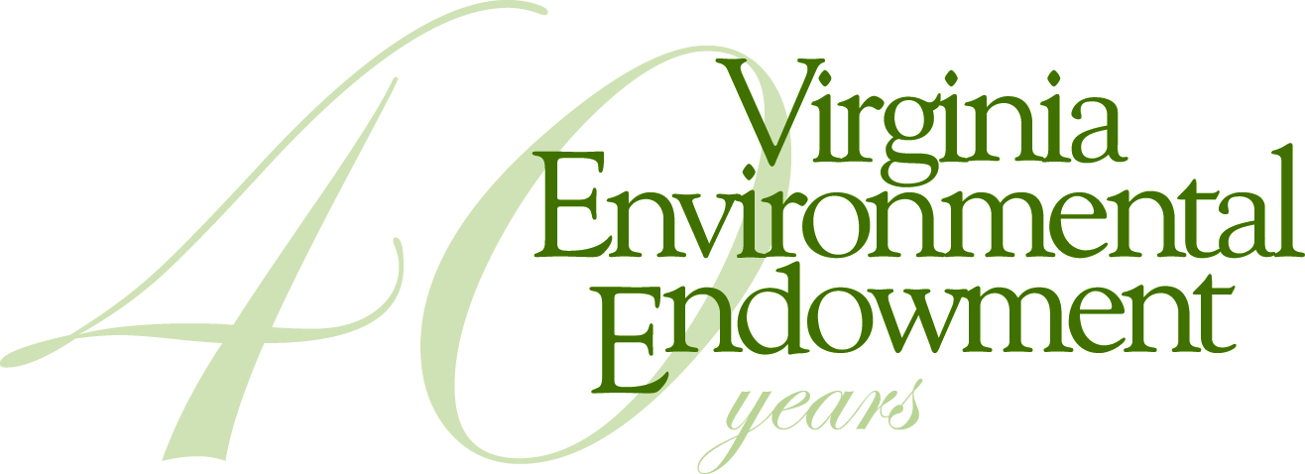

FOR IMMEDIATE RELEASE

Contact: Joseph H. Maroon, Executive Director
info@vee.org / 804.644.5000

VIRGINIA ENVIRONMENTAL ENDOWMENT AWARDS
MORE THAN A QUARTER MILLION DOLLARS FOR REGIONAL PROJECTS

Dec 13, 2017 - Rounding out a year of 40th Anniversary initiatives, the Virginia Environmental Endowment (VEE) is pleased to announce awards of $253,200 to ten organizations dedicated to protecting and improving the region’s natural resources and environment, bringing total awards in 2017 to more than $500,000. When combined with matching funds, VEE has achieved more than $80 million in environmental improvements since it was founded in 1977.

“For four decades, the Virginia Environmental Endowment has been honored to support partners whose work reflects our commitment to preserving and protecting our incredible natural resources,” said Joseph H. Maroon, VEE Executive Director. “These latest grants continue our focus on the critical issues of water quality, Chesapeake Bay restoration, land conservation, environmental literacy and public awareness, and climate adaptation and resiliency planning for coastal communities. We are also very pleased to continue to support important water quality efforts in portions of West Virginia and Kentucky.”

VEE will also provide $10,000 to the nonprofit American Documentary Film Fund for the creation of a film honoring the legacy of the late U.S. Judge Robert R. Merhige, Jr., who presided over the court settlement that led to the Endowment’s creation.

Other Virginia, West Virginia, and Kentucky grants, grouped by area of focus, are as follows:

Environmental Education

The City of Hopewell, Hopewell, VA: The City recreation and parks department will receive a grant from VEE for the installation of a series of environmental education signs for the new Hopewell Riverwalk, to be constructed along the Appomattox River shoreline. The interpretive signage will tell the story of the river, the strategies and methods employed to return the river to healthier conditions, and the importance of river health and its impact on everyday life. ($20,000)

Chesapeake Bay Outreach

Alliance for the Chesapeake Bay, Annapolis, MD: Support to engage local governments in restoring water quality in the Chesapeake Bay and its Virginia tributaries, with a series of roundtables hosted by local elected officials throughout the remainder of 2017 and in 2018. ($17,850)

Bay Journal Media, Annapolis, MD: Continued support of the Bay Journal’s coverage of important Bay related issues in Virginia and the publication of the new local government edition. ($25,000)

Water Quality Protection in Virginia

Virginia Conservation Network, Richmond, VA: Support for the “Clean Water for All Virginia” program, in conjunction with a national campaign to help coordinate efforts of diverse groups to protect clean water safeguards and important federal environmental standards that impact all communities. This campaign will also help advance clean water protections in Virginia and within the Chesapeake Bay watershed. ($30,000)

Land Conservation

Historic Virginia Land Conservancy, Williamsburg, VA: Support for completion of legal and other documents that will help to expand the land conservation efforts of the Historic Virginia Land Conservancy (HVLC) into localities on the Middle Peninsula. HVLC, considered one of the premier land trusts in Virginia, has previously worked in the Lower James River and York River watersheds from King William County to Suffolk. ($12,500 challenge grant)

Living River Restoration Trust, Portsmouth, VA: Continued support for the Trust’s growth as the first local land trust working to conserve land in the Elizabeth River watershed including possible pioneering efforts using land conservation to help mitigate the impact of rising sea levels. ($15,000 challenge grant)

Climate Change and Resiliency Planning

University of Virginia’s Institute for Environmental Negotiation, Charlottesville, VA: Support for the implementation of the Resilience Adaptation Feasibility Tool (RAFT) in three pilot communities – Cape Charles, Portsmouth, and Gloucester County. The RAFT project offers an unusual opportunity to develop innovative and meaningful approaches helpful to coastal localities facing the challenges of increasing coastal storms, flooding, and sea level rise. ($25,000)

Water Quality Protection In the Kanawha and Ohio River Valleys

West Virginia Rivers Coalition, Charleston, WV: Ongoing support for WVRC’s efforts to defend state water quality standards and promote access to safe drinking water and water-related recreational opportunities. As the only statewide nonprofit organization focused on improving the health of the state’s waters, the West Virginia Rivers Coalition is a leading voice for clean water policies in the Mountain State. ($80,000 over 2 years)

Watershed Watch in Kentucky, Frankfort, KY: Support for the core water sampling program collected by volunteer citizen scientists in eight local groups across Kentucky and efforts to reinvigorate the statewide Science Advisory Committee to help standardize and upgrade the water data collected. ($17,850)

To learn more about the Endowment, or to obtain additional information about the complete list of projects or organizations receiving funding, please contact Joseph H. Maroon at info@vee.org or (804) 644.5000 or visit vee.org.

The Virginia Environmental Endowment (VEE) is a non-profit, grant-making foundation based in Richmond, Virginia that is focused on improving the quality of the environment by using its capital, expertise and resources to encourage all sectors to work together to prevent pollution, conserve natural resources and promote environmental literacy. The Endowment is celebrating its 40th Anniversary in 2017. Learn more about VEE by visiting vee.org.

P.O. Box 790, Richmond, Virginia 23218-0790 · 804.644.5000

